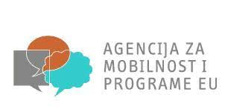
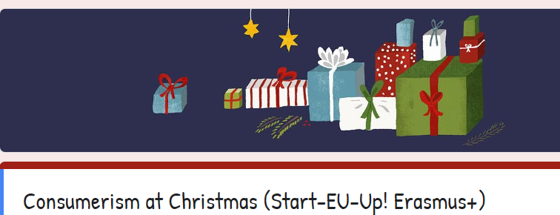

1. What does Christmas mean to you?
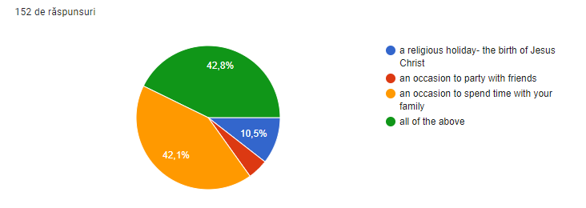2. In the run up to Christmas, which of the following statements are anxieties you have experienced?
-I’ve only got X days left to do my Christmas shopping
-I’ve thought of the perfect gift for X but will now have to spend more on X than I planned so that I’m -not spending more on one person than the other
-I find a busy high street stressful but I need to do my shopping
-I don't know whether I should buy X a gift or not
-I can't afford to get everyone gifts so need to find money from somewhere
-What if X doesn't spend as much on me as I have on them - this may embarrass them.
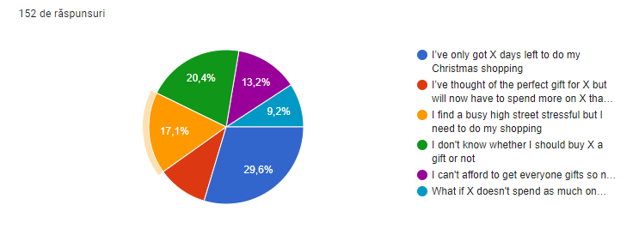
3. Adults tend to spend money at Christmas without critical thinking. For example people may justify their seasonal spending habits with phrases as simple as “…it’s Christmas”.”
Do you agree?
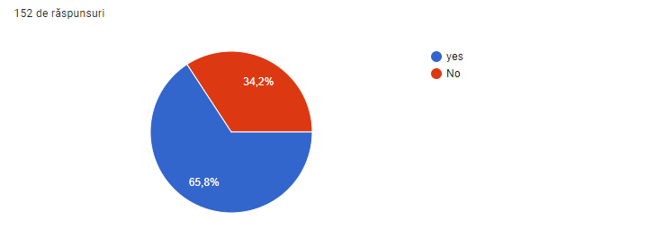

4. Have you (your family) ever struggled financially in January as a result of your spending habits over the Christmas period?
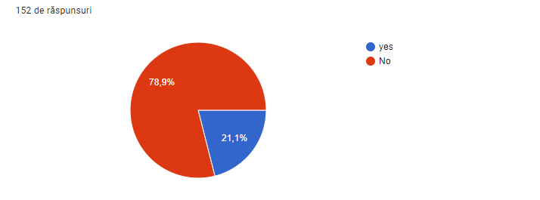
5. If you didn't have the financial means to buy any Christmas gifts this year, rate which of the following you'd be most likely to do (1 being most likely, 4 being least likely)
- I'd make gifts or offer chores (bake cakes, wash cars, make some artwork etc)
-Take out some form of loan such as credit cards/overdraft/bank loan to cover the cost of gifts
-Explain to my family and friends that I won't be doing gifts this year
- I'd get a seasonal job to supplement my main income and cover the cost of gifts
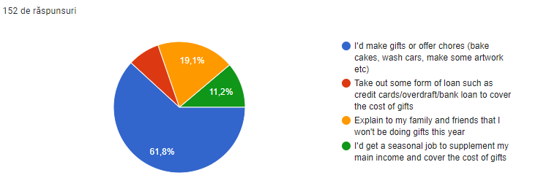

6. Can you remember more than 5 Christmas gifts you received in 2015?

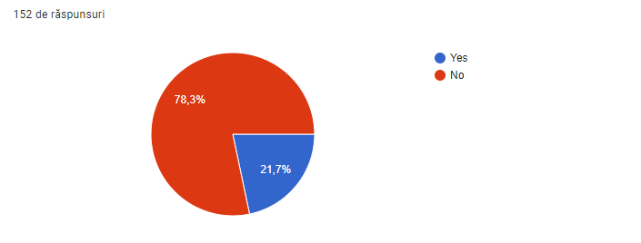
7. How much money do you usually spend on Christmas (presents, food, etc)
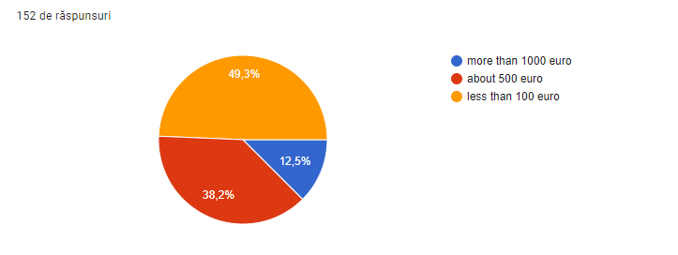
8. Does your family often cook too much food for Christmas?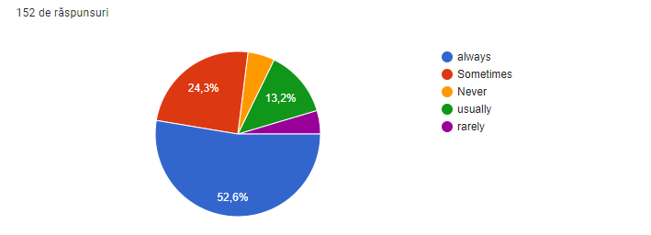
9. What kind of Christmas tree do you prefer?
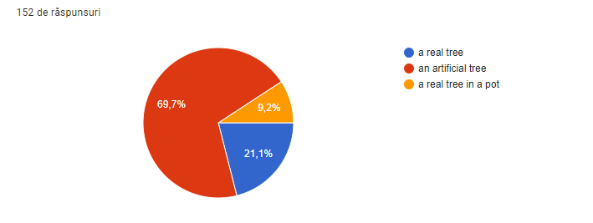

10. Who does the Christmas shopping in your family?
