Video: Pupil exchange visit to Irish Embassy and Dinamo Zagreb Stadium
We were invited to the Irish Embassy in Zagreb by ambassador Olive Hempenstall. She explained the work of the embassy and notable links between Ireland and Croatia.
Our visit to Dinamo Zagreb stadium was also great. The facilities in the stadium were fantastic with players’ bedrooms, gym, sauna, massage rooms and even an oratory. The video below shows the highlights of the day.

https://youtu.be/k_eQ8eqRWdQ

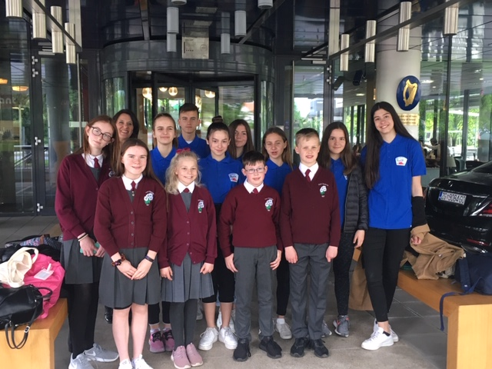

Video: Irish dancing, Gaelic football and other activities in Zagreb
It was a fun-filled week in Croatia – visiting Zagreb Zoo, Bundek lake and park by the Sava River, Veternica Cave at Park Prirode, Medvednica, Nikola Tesla Museum and coal mines.
The pupils introduced their Croatian friends to Irish dancing and football. We cannot thank our Croatian friends enough (teachers, parents and pupils) for their huge amount of work in preparing such a memorable trip and taking care of Aoife, Cathal, Evan, Kellyann and Ruby.
Thanks also to Michelle Gannon for accompanying us and being such a great help. The video linked to this article shows the broad range of activities that the pupils took part in during the week.
https://youtu.be/jM1SE61YoPk

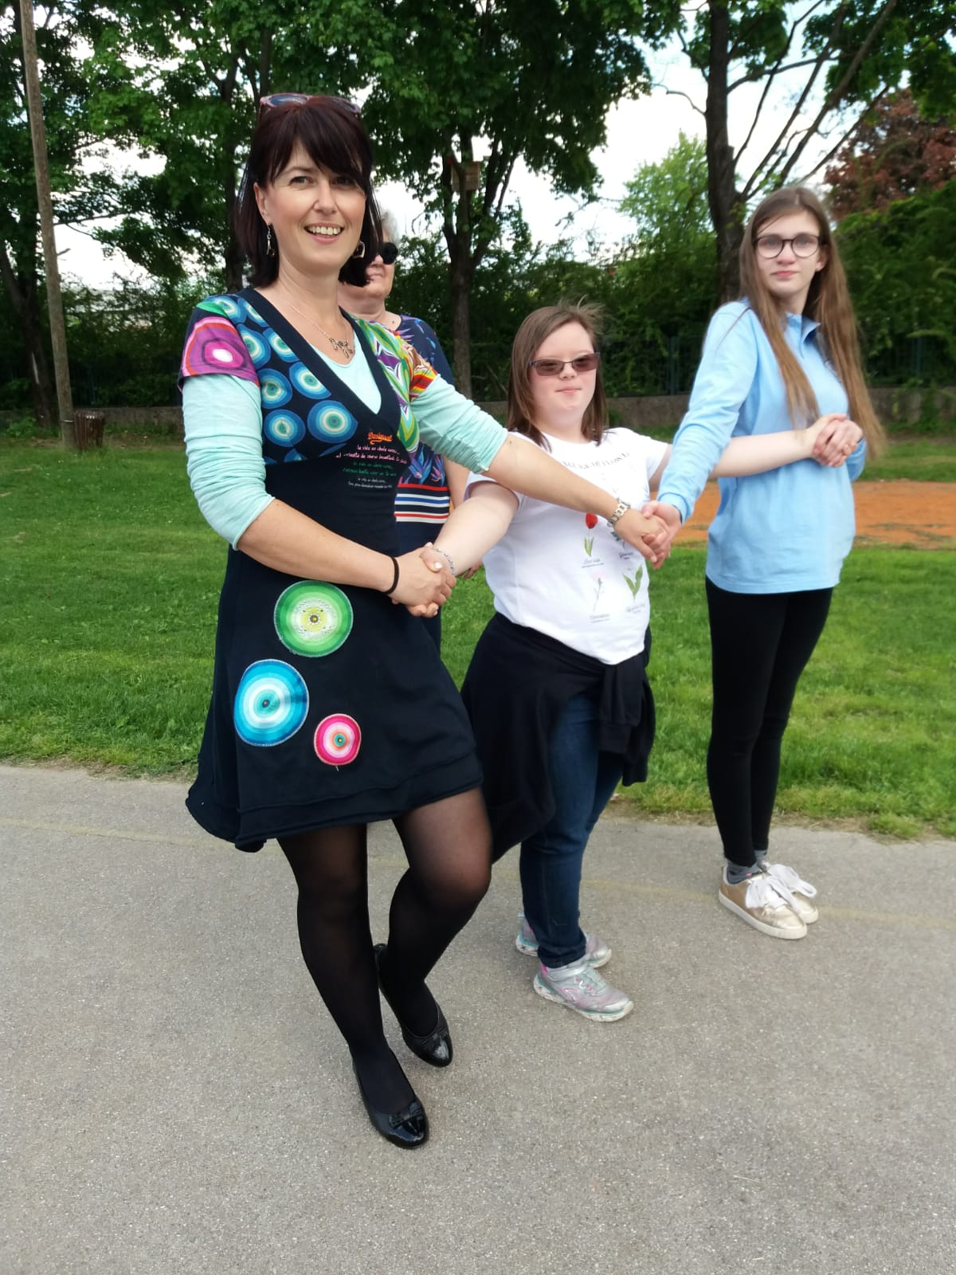

A story from Croatian partners
http://www.learn-play-ict.com/2018/10/19/a-story-from-croatian-partners/

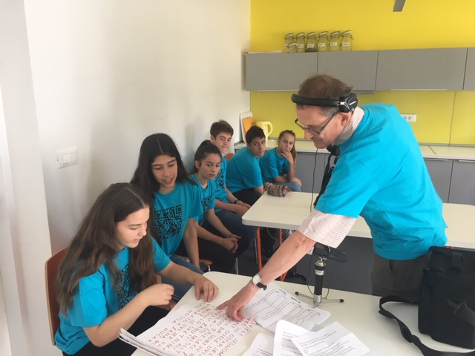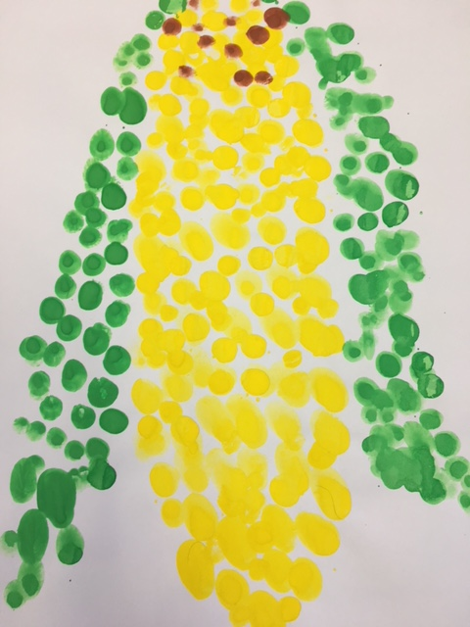

Quiz Game on Europe – Croatian version
http://www.learn-play-ict.com/2019/03/12/quiz-game-on-europe-croatian-version/

