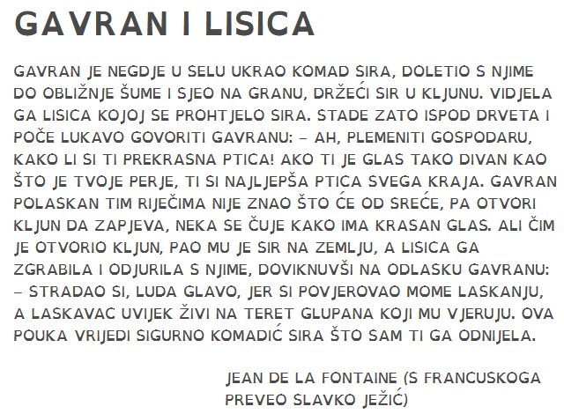

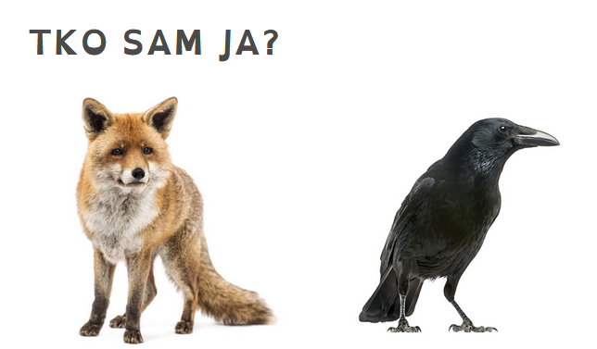

_______________________ __________________________

_______________________ ___________________________

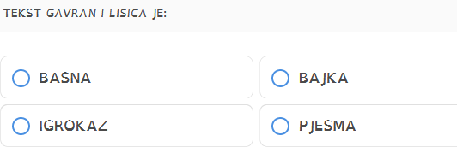

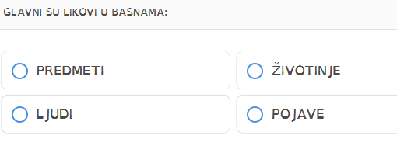

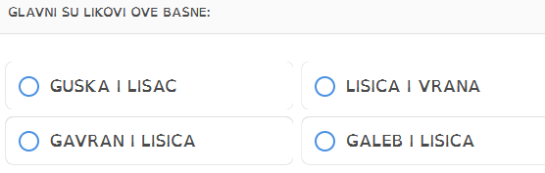

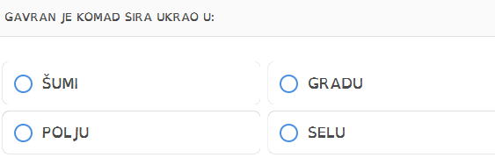

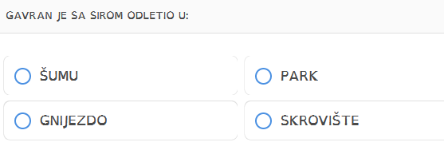

PREPIŠI REČENICICE PRAVILNIM REDOSLJEDEDOM



1. _____________________________________________________________
2. _____________________________________________________________
3. _____________________________________________________________

