STVARNI OPIS

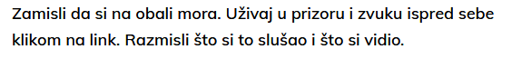

https://wke.lt/w/s/yR9b-t

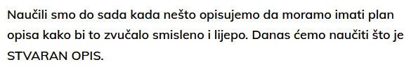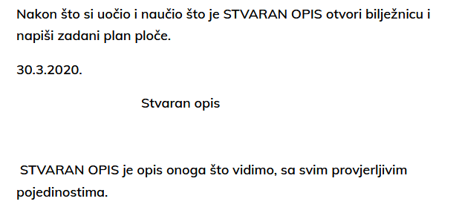

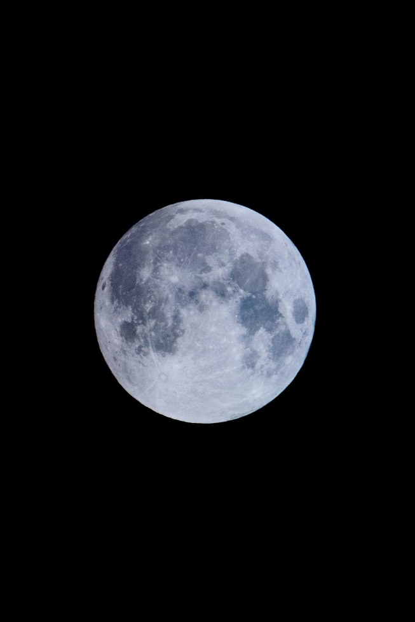

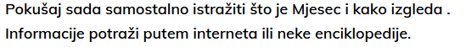

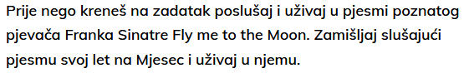

https://wakelet.com/wake/49f53b30-2b2d-406e-b9ef-4d4434390a2c

