ŠTO PRIKAZUJU SLIKE? NAPIŠI!

PAZI NA PISANJE IJE / JE

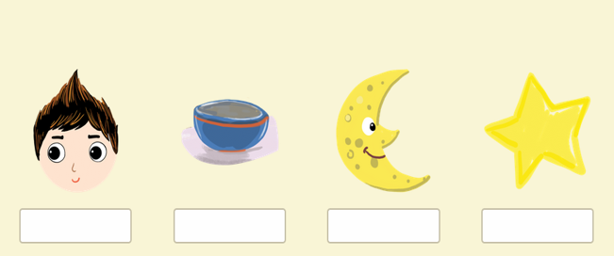

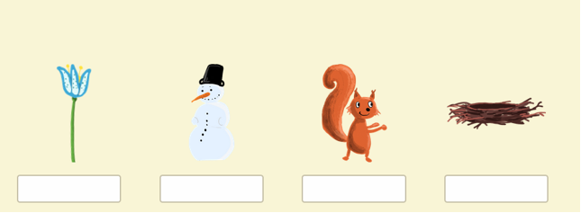

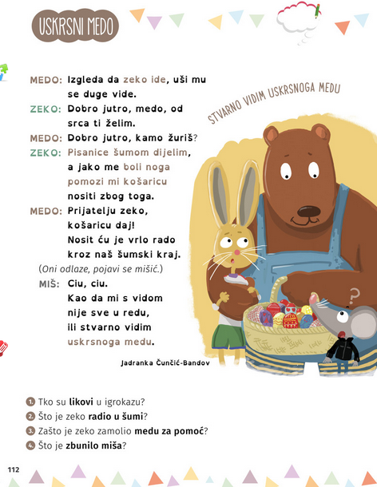

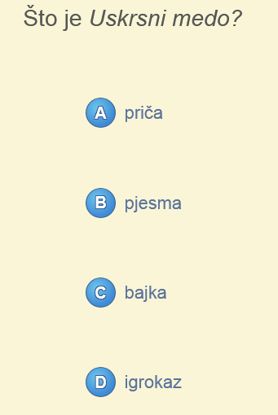 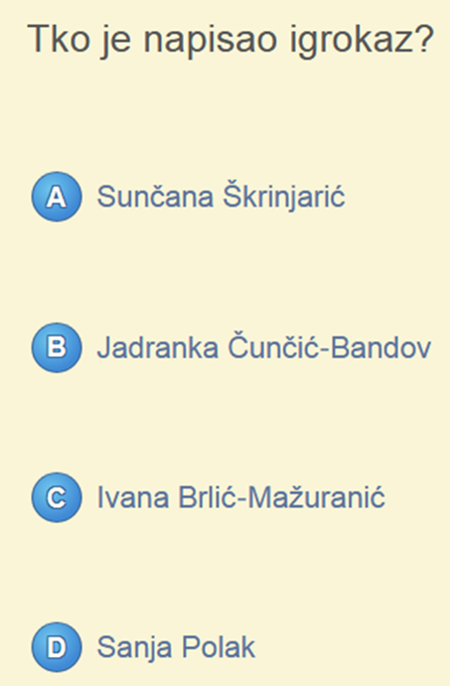

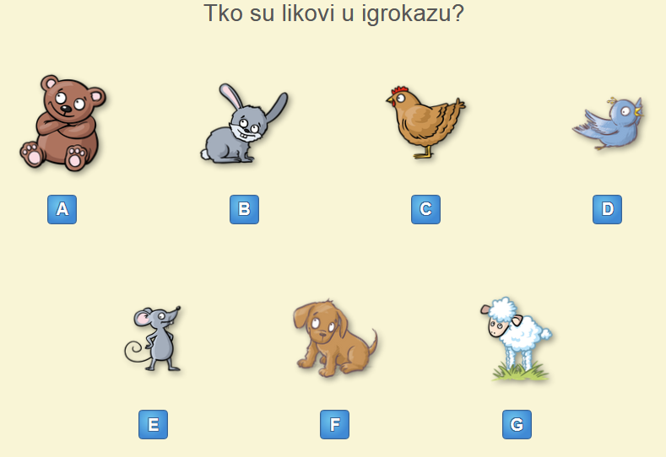

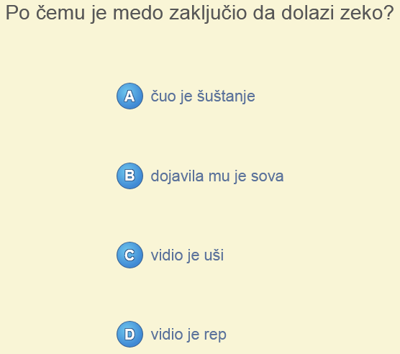

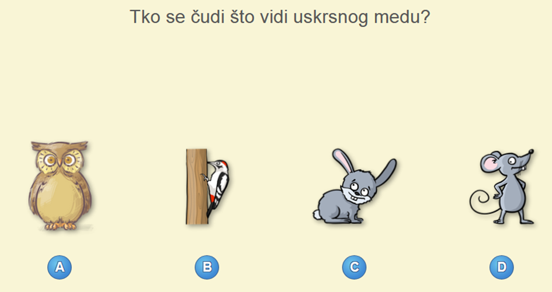

NAPIŠI KAKO IZGLEDA USKRSNI ZEC.

__________________________________________________________________________________

_________________________________________________________________________________