**DRAGA DJECO,**

**U NASTAVKU SLIJEDE MATERIJALI KOJIMA ĆETE PONOVITI MNOGE STVARI KOJE STE DO SADA NAUČILI. ZA VAS SU PRIPREMLJENI LISTIĆI IZ HRVATSKOG JEZIKA I MATEMATIKE. NEMOJTE SE ZABORAVITI I RAZGIBATI :)**

**VELIKI POZDRAV,**

**UČITELJICA MARIJA**

**ZAOKRUŽI TOČNO NAPISANU RIJEČ**

|  |  |
| --- | --- |
| **šal vuk**  **ćuk jež**  **kos koš**  **fen sol** | **mač sok**  **sos konj**  **malj uho**  **lav miš** |
| **noć pet**  **osa oko**  **pas noj**  **nož peć** | **uho kos**  **nos bos**  **sos sok**  **vuk noj** |

**DOPUNI REČENICE**

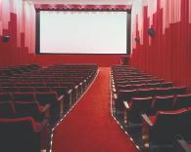



ANTE IDE U ____________ .

 ________



MAMA IMA ___________ .

 VODA JE U ___________ .



SANJA ZNA __________ .





IVAN VOLI PITI _____________ .



________________ IMA PERO.

___________________ IMA ROG.



MATO JEDE ________________.

___________________ JE ŽUTO.

**ODGOVORI NA PITANJE**

**1. Mama kuha juhu.**

**a) Što radi mama? ________________________**

**b) Tko kuha juhu? ________________________**

**c) Što mama kuha? ________________________**

**2. Tata vozi auto.**

**a) Tko vozi auto? ________________________**

 **b) Što tada radi? ________________________**

**c) Što tata vozi? ________________________**

**3. Tanja šeće.**

**a) Što radi Tanja? ________________________**

**b) Tko šeće? ________________________**

**4. Ivu boli zub.**

**a) Koga boli zub? ________________________**

**b) Što boli Ivu? ________________________**

**5. Konj jede zob.**

**a) Što jede konj? ________________________**

**b) Tko jede zob? ________________________**

**SPOJI BROJ I OZNAKU**

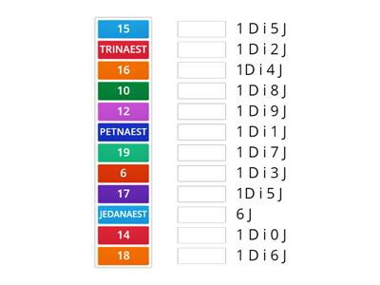

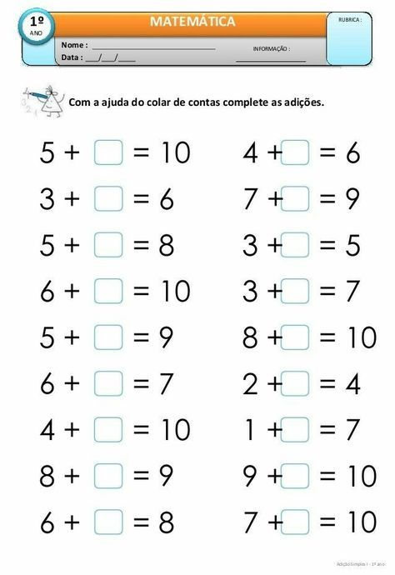**UPIŠI ODGOVARAJUĆI BROJ**

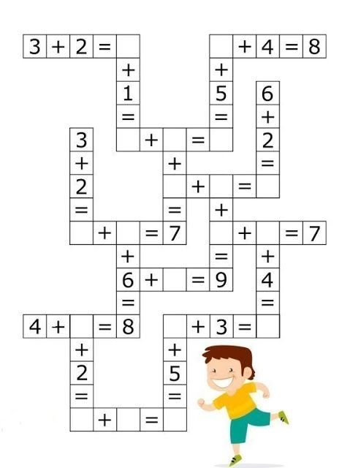**ZBROJI**

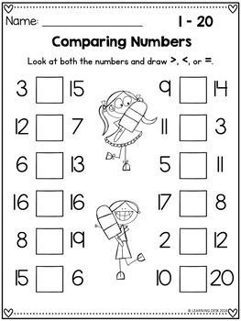**USPOREDI**

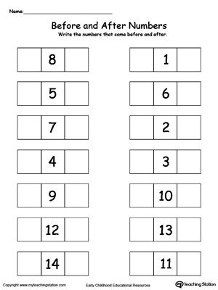**NAPIŠI PRETHODNIKE I SLJEDBENIKE BROJA**

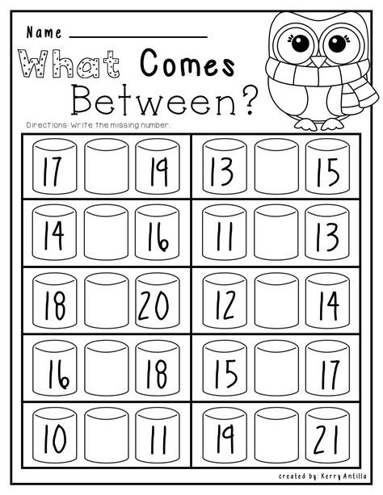**NAPIŠI BROJ KOJI SE NALAZI IZMEĐU BROJEVA**

**ODUZMI**

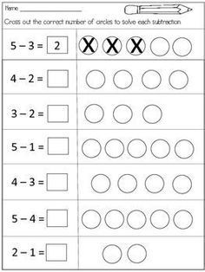

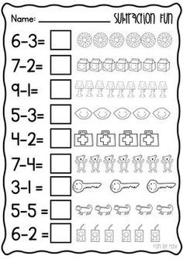**ODUZMI**

**TJELESNA I ZDRAVSTVENA KULTURA**

**1. VJEŽBE ZAGRIJAVANJA: https://www.youtube.com/watch?v=8M9gsu3lYHc**

**2. KARDIO VJEŽBE: https://www.youtube.com/watch?v=L_A_HjHZxfI**

**3. PLESNE STRUKTURE:**

[**https://www.youtube.com/watch?v=JC3k9RioSe0**](https://www.youtube.com/watch?v=JC3k9RioSe0)