HJ – PRAVOPIS – ponavljanje 9.4.2020.

- PROUČI :
https://www.e-sfera.hr/dodatni-digitalni-sadrzaji/426621c5-5c20-443b-bf4b-dc7733beea75/

https://hr.izzi.digital/DOS/1109/1321.html

- NAPIŠI NASLOV
- PREPIŠI U PISANKU RIJEČI (neka budu isto ovako u stupcima)
- DOPIŠI TOČNO SLOVO

Pravopis

1. Na prazne crte upiši slovo đ ili dž.

grož____e pi____ama
____ak ____ip
pan____e ____emper
____ur____ica ____ep
____em ____uro

2. Nadopuni riječi upisujući ije ili je.

ml____ko ____t
p____sma d____ca
d____te l____čnik
cv____tovi, cv____t,
d____vojčica, sr____da

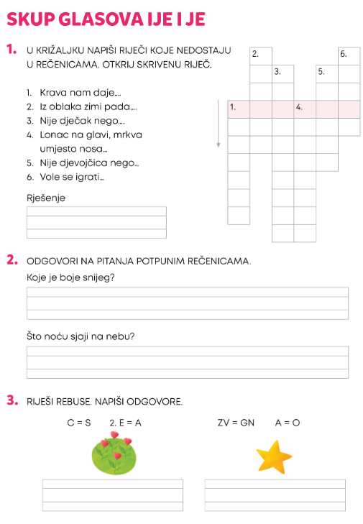
- ZALIJEPI I DOPUNI:

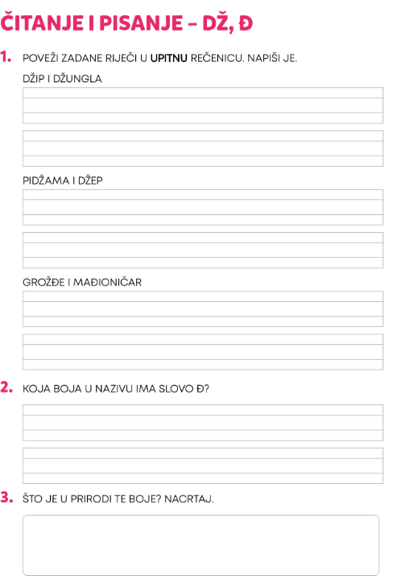

- PONOVI I VJEŽBAJ:
https://www.profil-klett.hr/kvizovi/prez/gotovi/data/hrvatski_na_dlanu_2/update/hnd_2_str_99__s/index.html
https://wordwall.net/hr/resource/374921/hrvatski-jezik/pisanje-glasova-%c4%8d-%c4%87-d%c5%be-%c4%91
https://wordwall.net/hr/resource/941382/izgovor-i-pisanje-rije%C4%8Di-ije-je
https://wordwall.net/hr/resource/669349/hrvatski-jezik/pisanje-nije%c4%8dnica
https://wordwall.net/hr/resource/752668/hrvatski-jezik/pisanje-rije%c4%8dce-li
https://wordwall.net/hr/resource/877629/hrvatski-jezik/pisanje-ije-je-%c4%8d-%c4%87-d%c5%be-%c4%91

