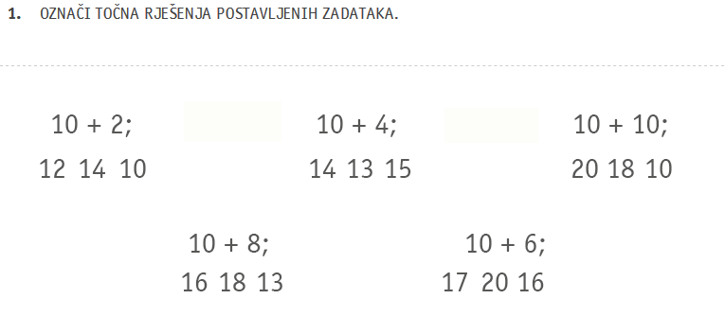
- ZBROJI.

- + 7 = ____ 9 + 5 = ____ 6 + 5 = ____
- 7 + 7 = ____

2 + 9 = ____ 4 + 9 = ____ 9 + 7 = ____
8 + 6 = ____

- ODUZMI.

12 – 8 = ____ 13 – 7 = _____ 15 – 6 = _____
11 – 4 = _____

18 – 9 = _____ 14 – 6 = _____ 16 – 8 = _____

