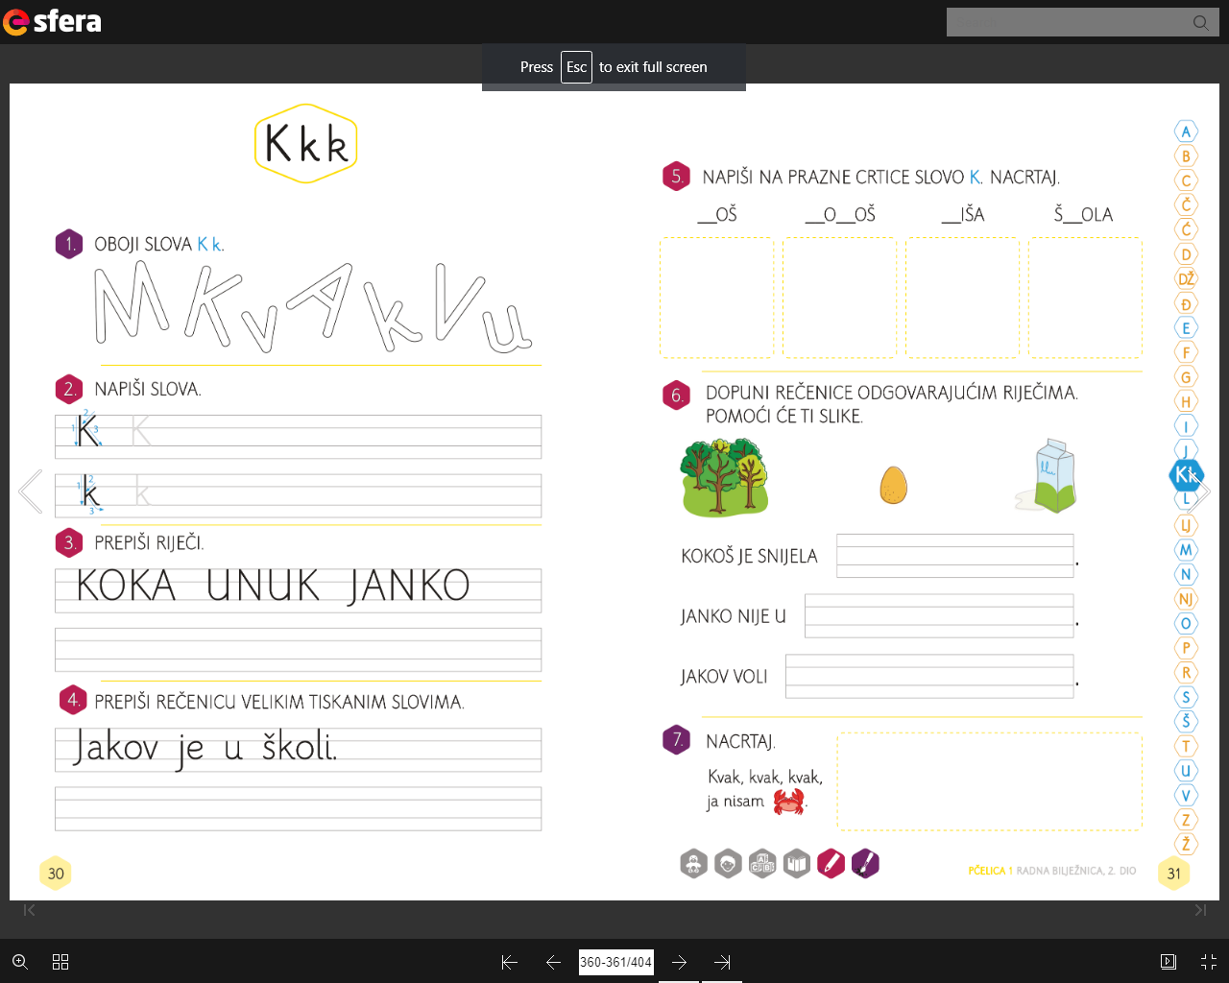

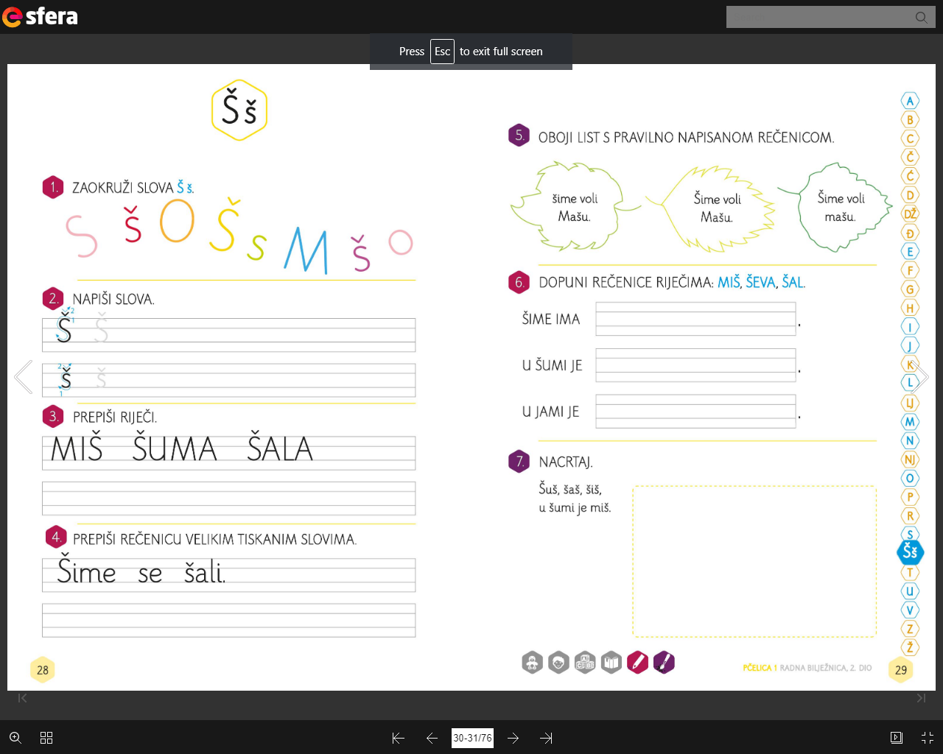

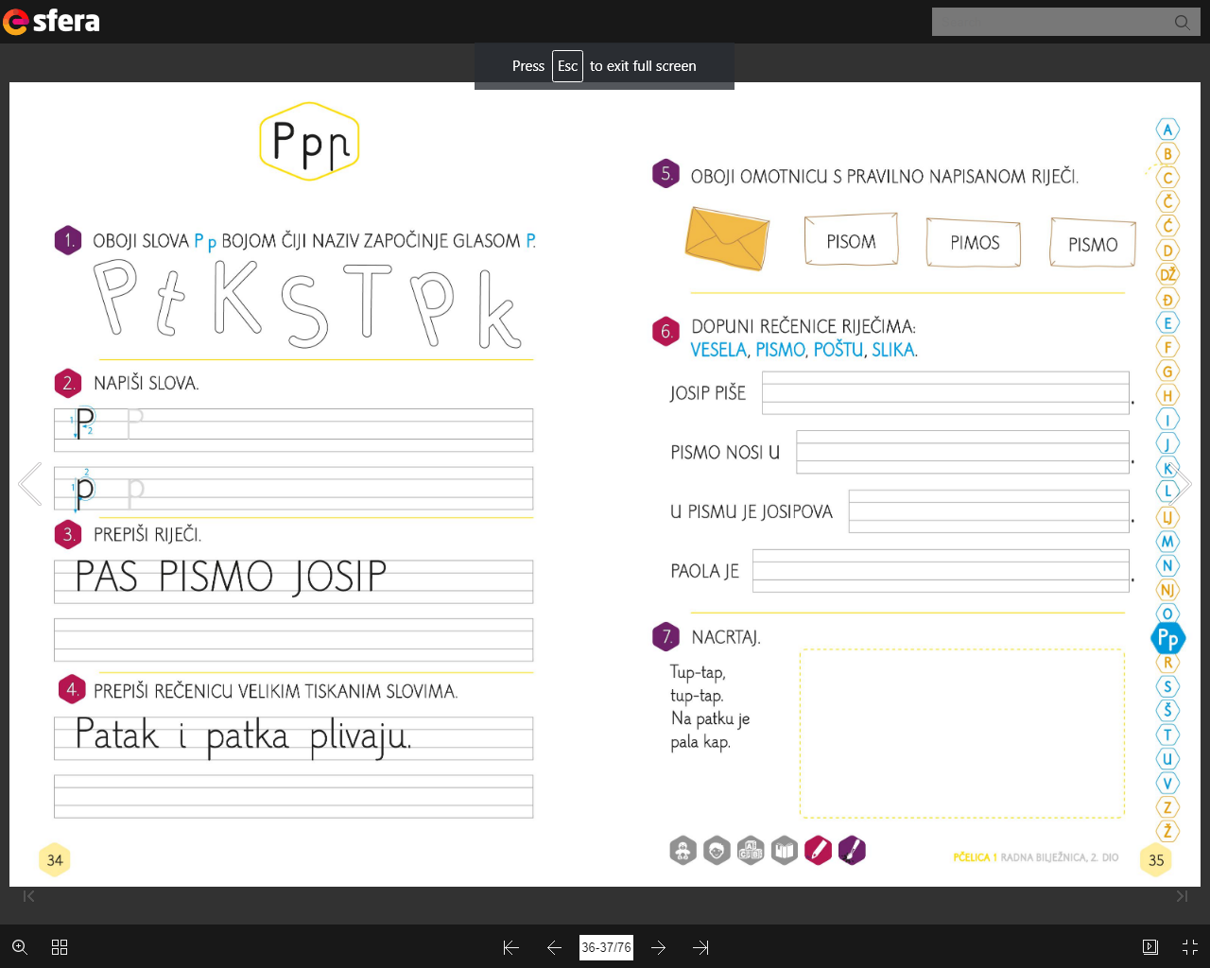

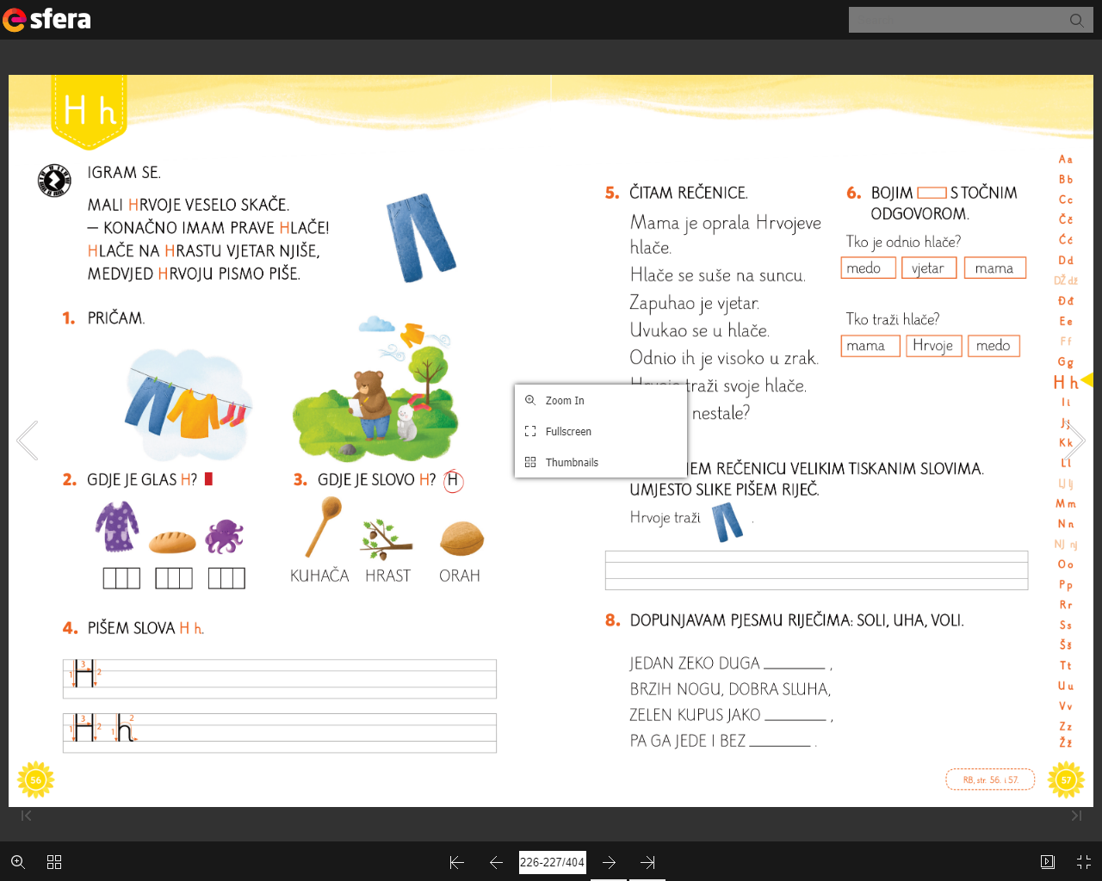

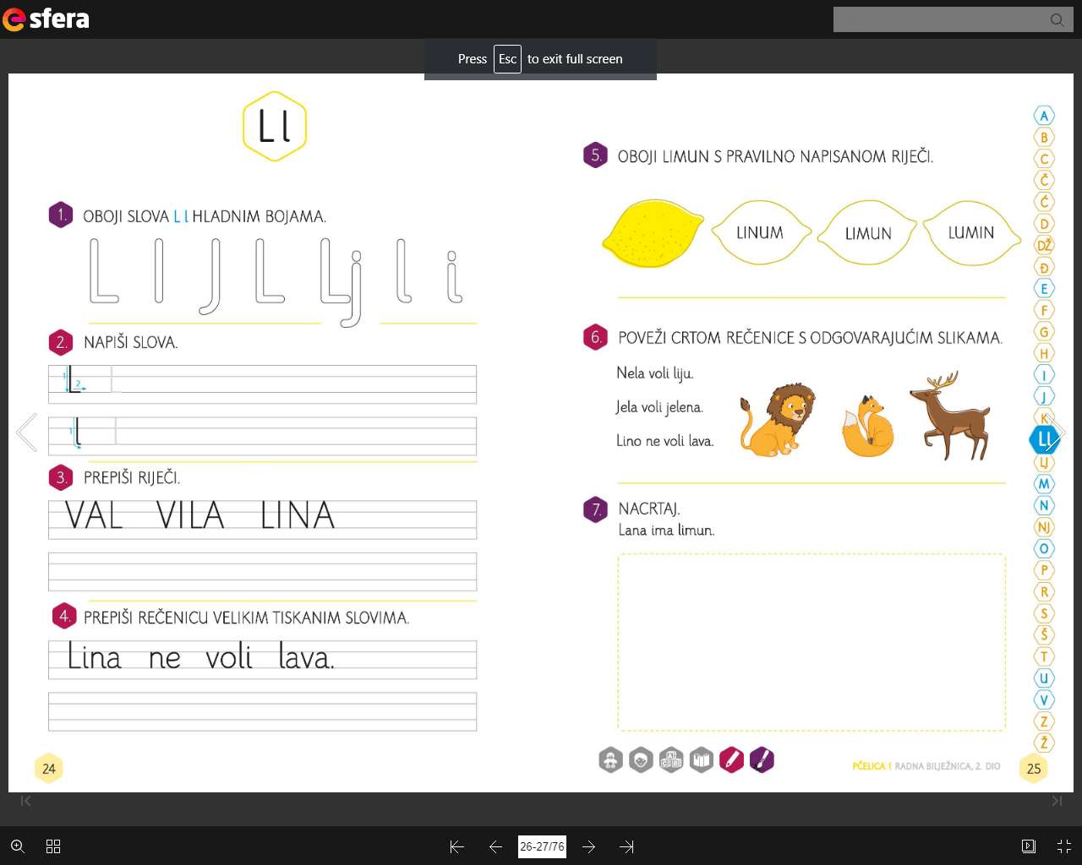

PREPIŠI REČENICE:

__________________________________________________

__________________________________________________

__________________________________________________

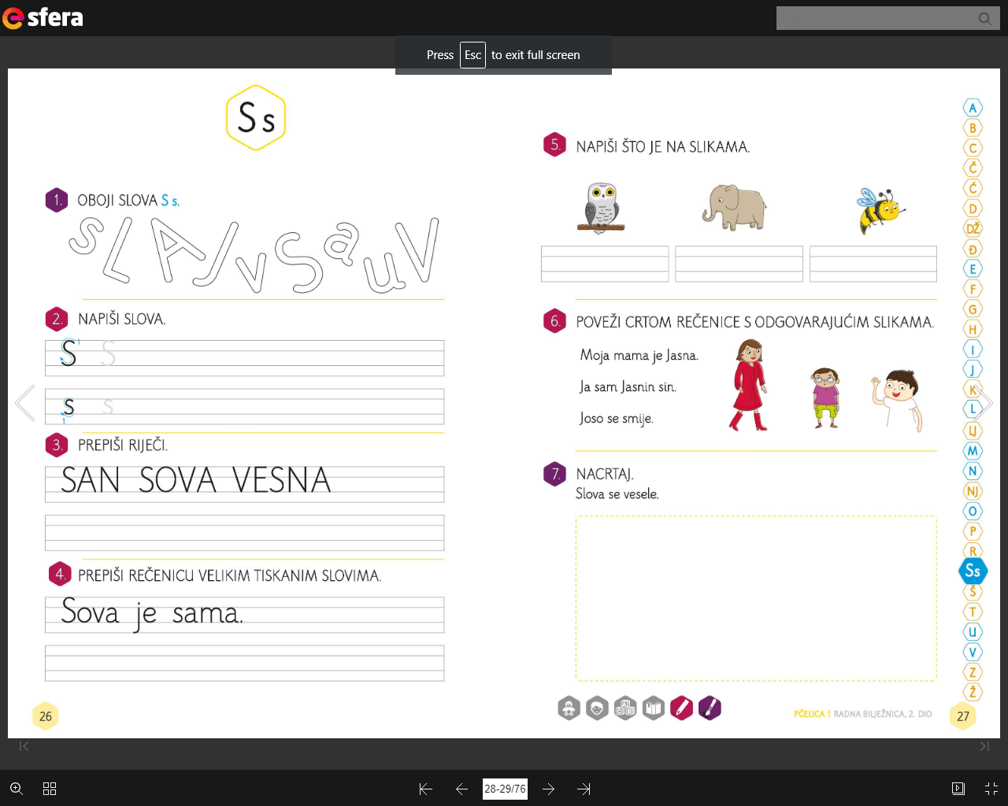

PREPIŠI REČENICE:

__________________________________________________

__________________________________________________

__________________________________________________