PID - Zanimanja ljudi 29.4.2020.
- Prouči sadržaje na linku: https://hr.izzi.digital/DOS/1109/3622.html https://www.e-sfera.hr/dodatni-digitalni-sadrzaji/30ce45b9-d5da-47a1-a193-d07af464c315/
- Pogledati slike i proučiti u UDŽBENIKU str. 78., 79.
- NAPISATI NASLOV. ZALIJEPITI. RIJEŠITI u pisanke.
Zanimanja ljudi
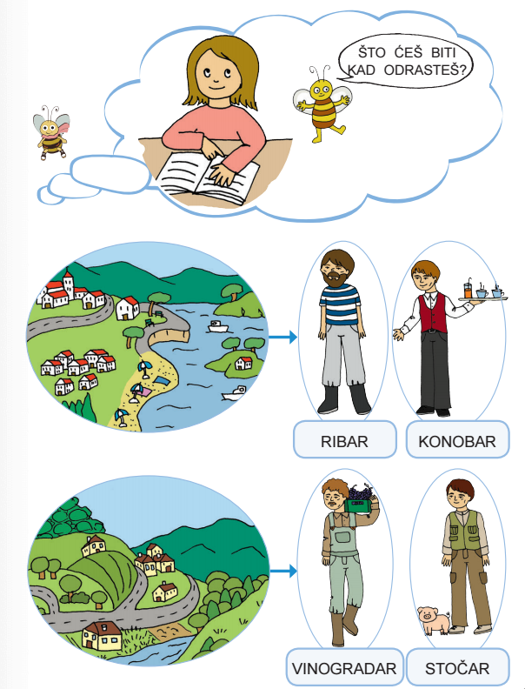

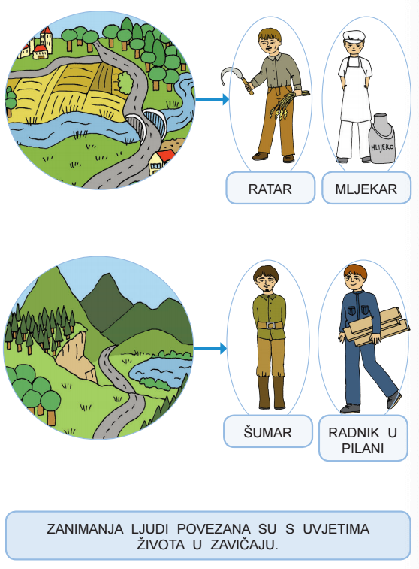

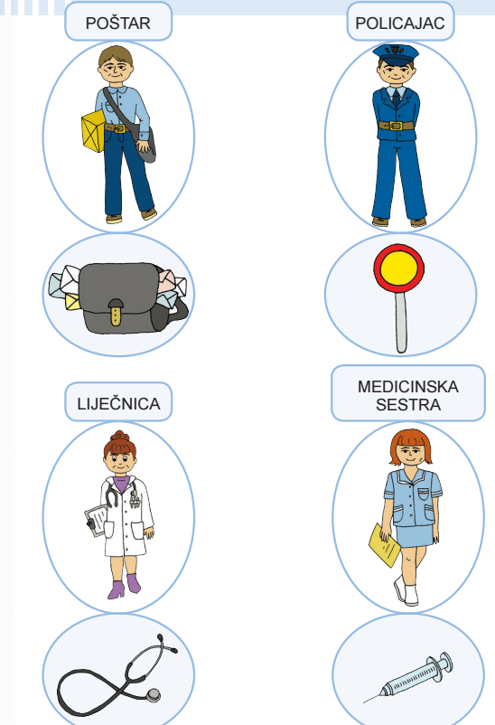

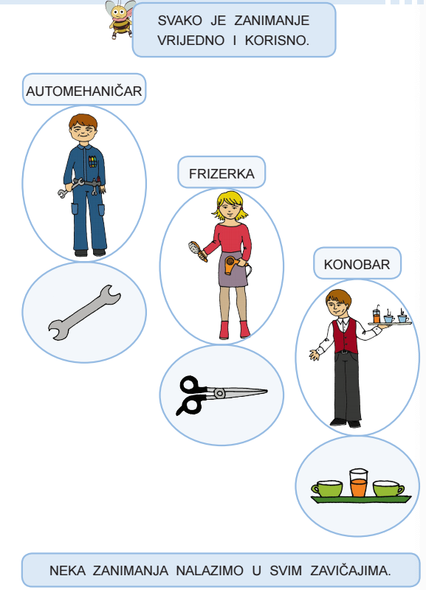

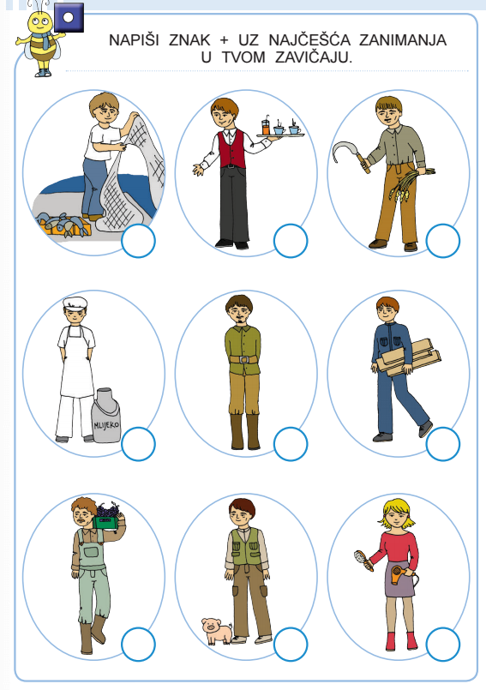

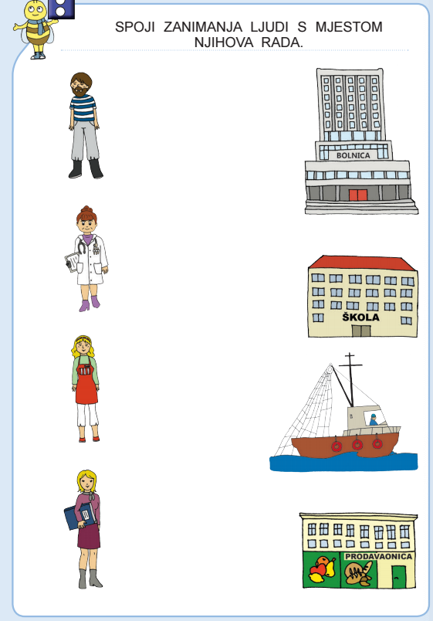

PONOVIMO
https://wordwall.net/hr/resource/320374/zanimanja-ljudi
https://wordwall.net/hr/resource/694935/zanimanja-ljudi
https://wordwall.net/hr/resource/1817765/priroda-i-dru%c5%a1tvo/zanimanja-ljudi-u-zavi%c4%8daju-2r

DZ – RB – str. 100., 101., 102.

