Upoznaj profesora Baltazara,
klikni na link:
https://prezi.com/kp3aojspu8va/profesor-baltazar/?utm_campaign=share&utm_medium=copy&fbclid=IwAR26pZ72V4GYUQfJ0KJDTwet6ysoVI4OyWA2jHYmbL4rQU7AwTajM9P7Idg
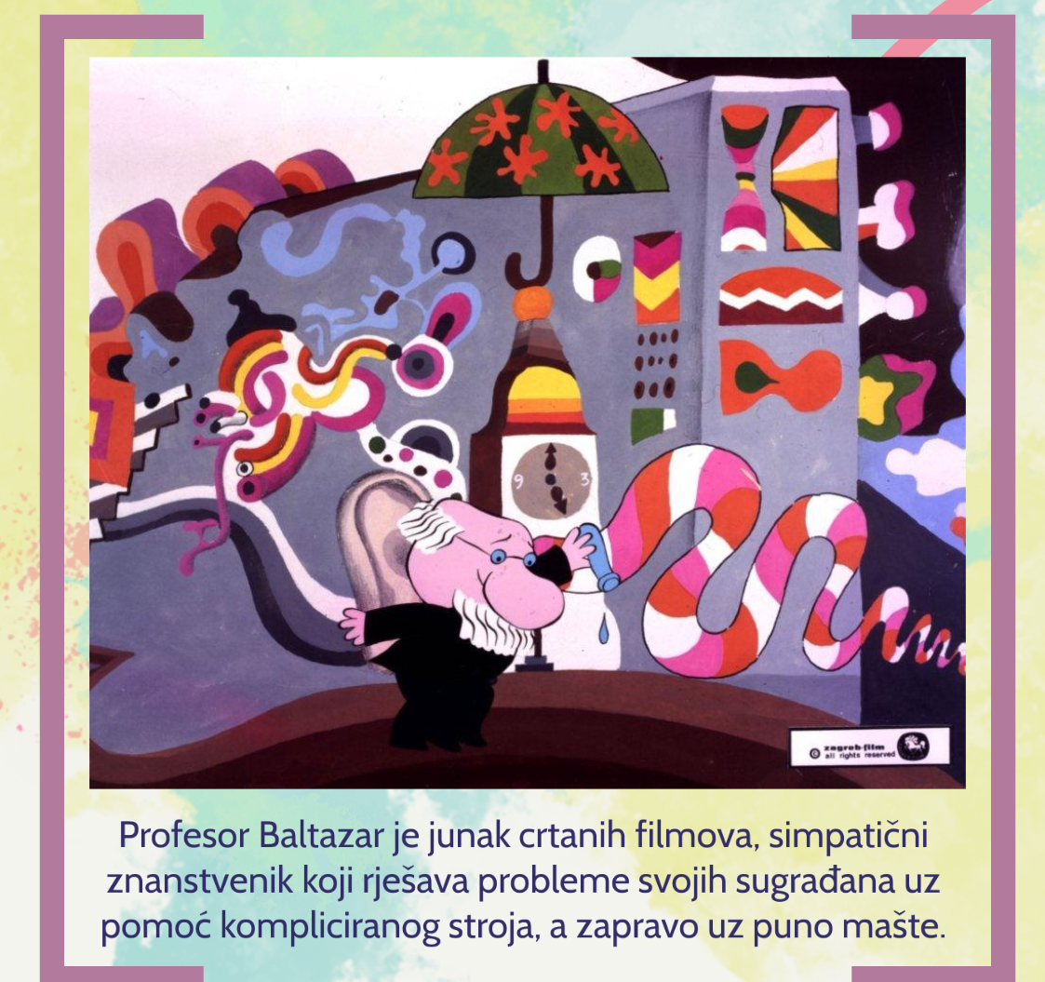

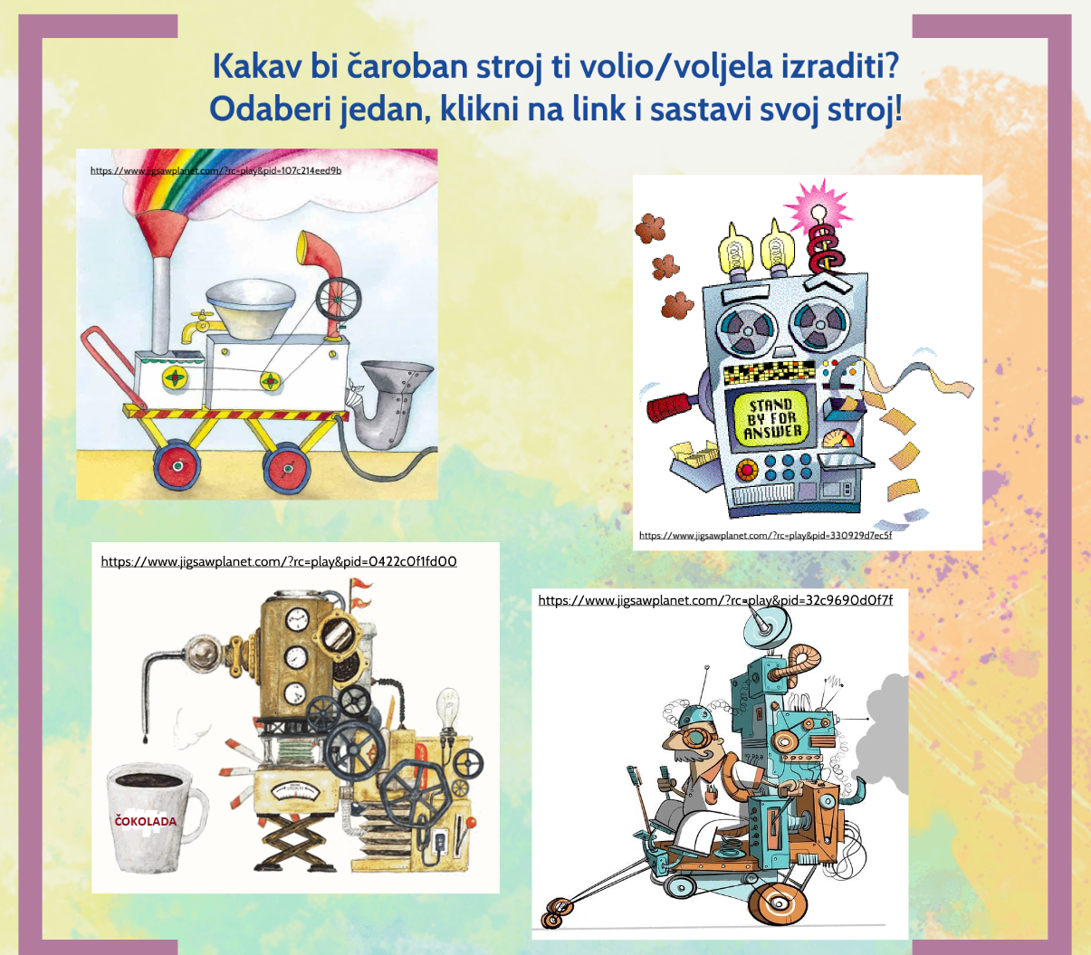

Kakav bi čaroban stroj ti volio/voljela izraditi? Odaberi jedan, klikni na link i sastavi svoj stroj!
https://www.jigsawplanet.com/?rc=play&pid=107c214eed9b
https://www.jigsawplanet.com/?rc=play&pid=330929d7ec5f
https://www.jigsawplanet.com/?rc=play&pid=0422c0f1fd00
https://www.jigsawplanet.com/?rc=play&pid=32c9690d0f7f

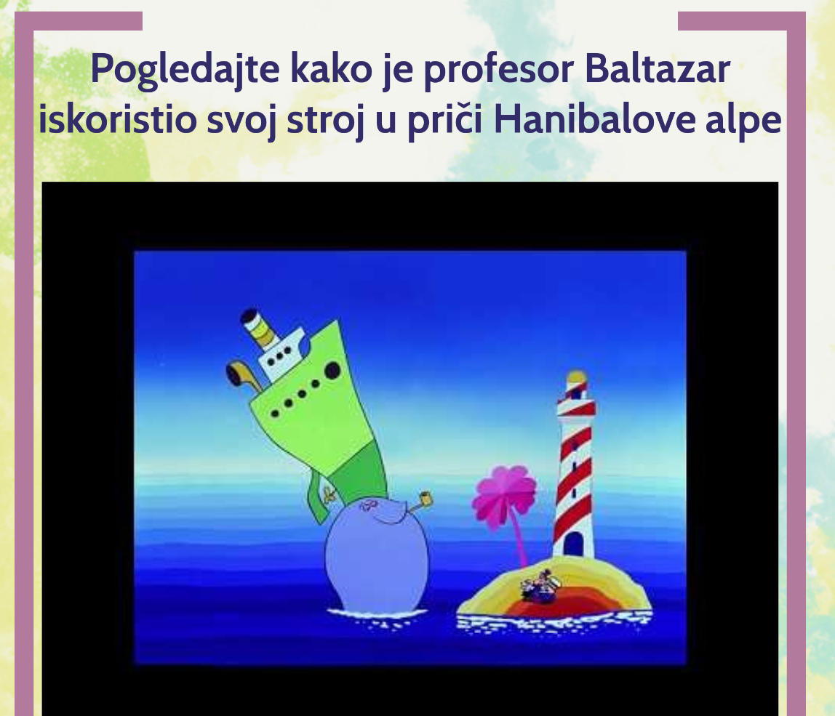
https://www.youtube.com/watch?v=9QNah2BpgP0&t=7s

Za one koji žele:

