PID - Putujemo vlakom 13.5.2020.
- Prouči PPT prezentaciju
- Prouči sadržaje na linku: https://www.youtube.com/watch?v=QF9ng9Ip8B0&feature=youtu.be&fbclid=IwAR1cTkTD3SDACkUp5NXLkb8nR3GxpNbCYYqh6I5sWjTUoeCAfuJEXT6Vn5E
https://www.powtoon.com/online-presentation/bdJW7IisrJv/?mode=movie&fbclid=IwAR25c6a4O6MTHUoKRXz_lff1IhM4wH1NSM9ZU8YDmgXXhbFeLtd8lAsWPWs
https://www.e-sfera.hr/dodatni-digitalni-sadrzaji/27133f38-6297-4f55-b6be-557a5f6878ce/
- Pogledati slike i proučiti u UDŽBENIKU 52., 53. str.
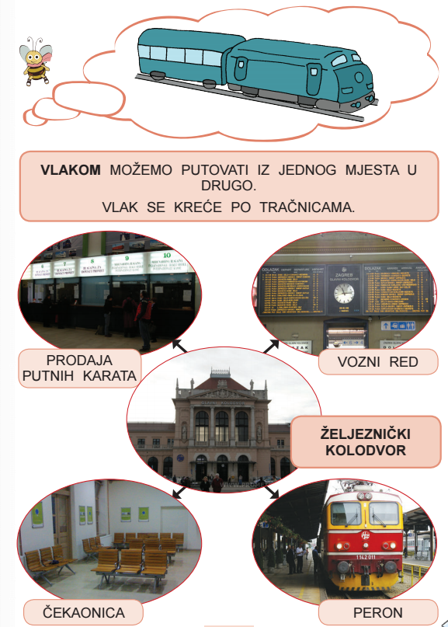
- NAPISATI NASLOV. ZALIJEPITI. RIJEŠITI u pisanke. Putujemo vlakom

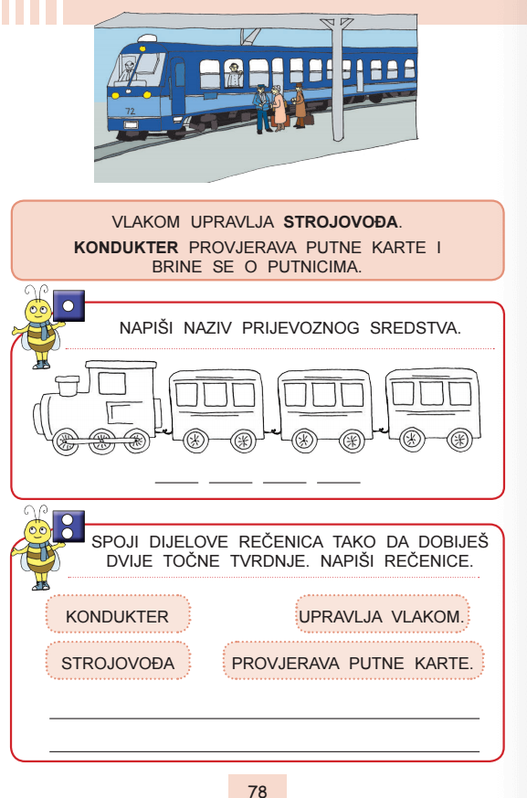

PONOVIMO
https://wordwall.net/hr/resource/2299430/priroda-i-dru%c5%a1tvo/putujemo-vlakom
https://wordwall.net/hr/resource/1545902/putujemo-vlakom

DZ – RB – str. 66., 67., 68.

