1.

|  |  |  |  |  |  |  |  |  |  |  |  |  |  |
| --- | --- | --- | --- | --- | --- | --- | --- | --- | --- | --- | --- | --- | --- |
| 36 | 4 | = |  | 20 | 4 | = |  | 27 | 9 = |  |  | 7 = | 7 |
| 1 | 8 | = |  | 30 | 6 | = |  | 8 | = | 32 |  | 4 = | 5 |
| 36 | 6 | = |  | 4 | 7 | = |  | 5 | = | 30 | 2 | = | 14 |
| 2 | 7 | = |  | 5 | 8 | = |  | 35 | = | 5 | 48 | = | 8 |
| 63 | 9 | = |  | 72 | 8 | = |  | 6 | = | 48 | 6 | 9 = |  |
| 5 | 6 | = |  | 28 | 4 | = |  |  | 9 = | 10 |  | 4 = | 7 |
| 81 | 9 | = |  | 9 | 4 | = |  |  | 8 = | 72 |  | 4 = | 4 |
| 4 | 4 | = |  | 3 | 7 | = |  | 24 | 8 = |  | 8 | = | 56 |
| 10 | 8 | = |  | 42 | 7 | = |  |  | 8 = | 8 | 63 | 9 = |  |
| 49 | 7 | = |  | 16 | 8 | = |  | 12 | 4 = |  |  | 7 = | 2 |
| 8 | 4 | = |  | 9 | 6 | = |  | 42 | = | 7 |  | 9 = | 72 |
| 60 | 6 | = |  | 9 | 9 | = |  | 2 | 8 = |  | 4 | = | 24 |
| 72 | 9 | = |  | 24 | 8 | = |  | 63 | = | 9 |  | 4 = | 9 |
| 10 | 7 | = |  | 6 | 8 | = |  |  | 6 = | 18 | 4 | 4 = |  |
| 5 | 9 | = |  | 24 | 4 | = |  | 7 | = | 49 | 24 | = | 4 |

/30 /30

3.

∙ 8

∙ 9

/10

|  |  |
| --- | --- |
| 6 |  |
| 3 |  |
| 9 |  |
| 7 |  |
| 5 |  |

|  |  |
| --- | --- |
|  | 63 |
|  | 45 |
| 9 |  |
|  | 36 |
| 8 |  |

|  |  |  |  |
| --- | --- | --- | --- |
|  | 4 | 3 |  |
| 5 |  |  |  |
| 6 |  |  |  |
|  |  |  |  |

I**me: .**



Množenje i dijeljenje 4.dio

2.

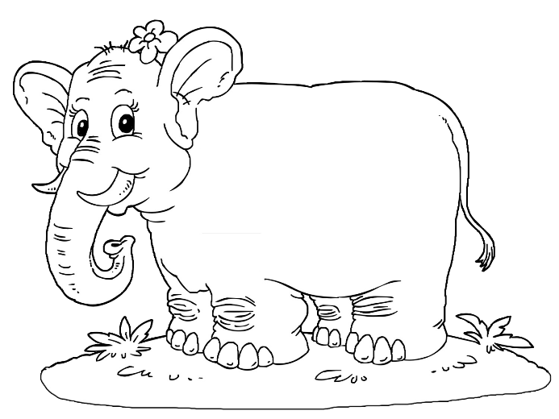

4.

/9

Bodovi: /79

Ocjena: