SECRET MESSAGE
For this experiment you will need: half a lemon, water, a glass, a hygiene stick (maybe a brush), paper and a lamp or bulb.
Squeeze the lemon, pour it into a glass, and add a few drops of water.
Write the secret message on white paper with a stick and wait for it to dry, so that the message becomes completely invisible.
When you are ready to read the secret message, heat the paper by holding it close to the bulb.
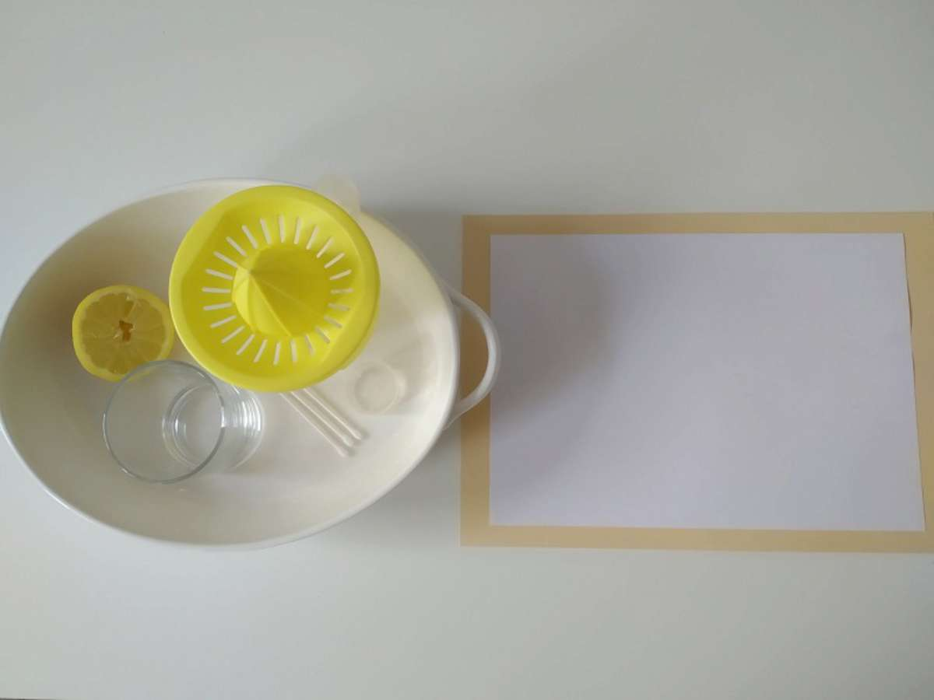

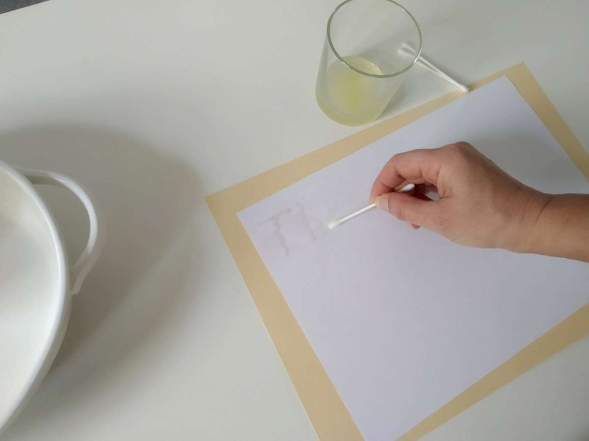
EXPLANATION:
Lemon juice is an organic substance that oxidizes and turns brown when heated. Diluted lemon juice and water is very difficult to notice on paper, no one will be aware of its presence until the paper heats up and shows a message.
Other substances that work in the same way are orange juice, honey, milk, onion, juice, vinegar and wine.

